Grade:IV Subtraction
How to check the answer of a subtraction?
Subtract 2157 from 5438 and check your answer.
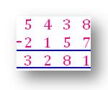
CHECK:
Add the DIFFERENCE to the smaller number.
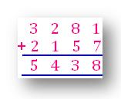
The answer will be the smaller number.
Subtract the DIFFERENCE from the greater number.
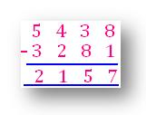
The answer will be the greater number.
In subtraction we will learn the subtraction operation of numbers having more than 4 digits with borrowing and without borrowing.

